Bucksburn Academy’s 10th Anniversary Kindness Challenge

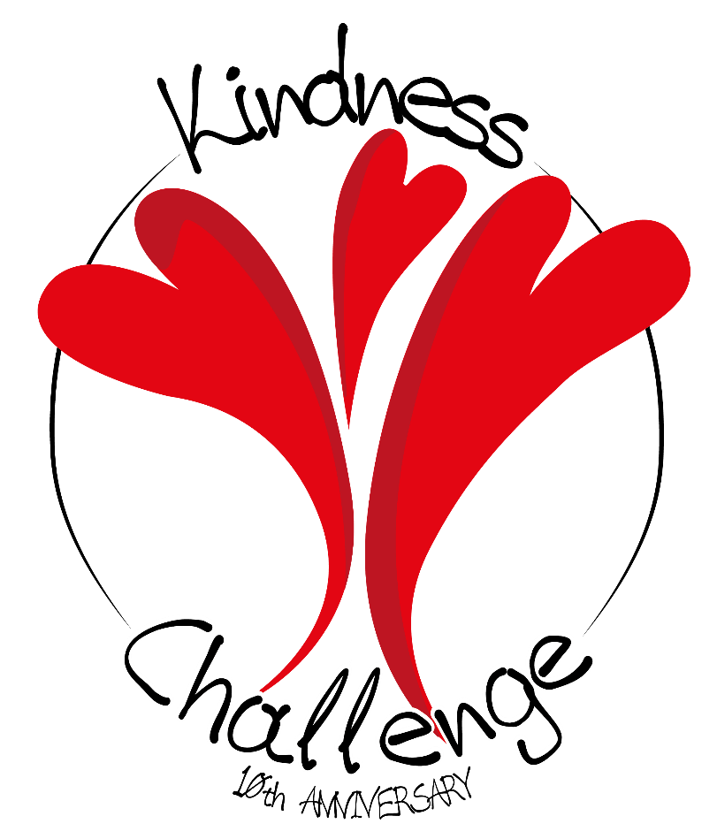
It is hard to believe that it is 10 years since Bucksburn Academy opened. We are planning on celebrating during the year by focusing on ‘random acts of kindness’ within the Bucksburn community. The idea is to highlight at least 10 acts of kindness happening over the next year. These acts of kindness can involve any person or group of people in not only our school community but also in the wider Bucksburn community. This could include groups such as Brownies/Guides, primary schools, activity groups, toddler groups, community council, church groups, or whoever has an idea.
It would be great if you could share this challenge with your community group and come up with a plan of how you could be involved in an act of kindness for others in our community. Please share your plans with us so that we can add it to our 10. We would like to share these acts of kindness on social media with the hashtag #buckburnkindness #bucksburn10.
Thank you to Enara, an S5 pupil and to Calum Gregge, a graphic designer at Stone Pony Digital for designing the kindness logo.
Please get in touch with fstephen@aberdeencity.gov.uk or the school office at Bucksburn Academy (01224 710700) if you have any kindness plans. Remember no idea is too big or too small. It is up to you.
Many thanks in anticipation.

